DATABASE MANAGEMENT LAB
LAB Report
Submitted in partial fulfilment of the requirement of the degree of
BACHELORS OF TECHNOLOGY
to

K.R Mangalam University


Submitted by: Submitted to
Harsh Bardhan Ms. Mansi Kajal
(2401010130)

Department of Computer Science and Engineering
School of Engineering and Technology
K.R Mangalam University, Gurugram- 122001, India
SESSION – 2025-2026

Experiment : 1

Question 1. Consider following databases and draw ER diagram and convert entities and relationships to relation table for a given scenario:

COLLEGE DATABASE
STUDENT (USN, SName, Address, Phone, Gender)
SEMSEC (SSID, Sem, Sec)
CLASS (USN, SSID)
SUBJECT (Subcode, Title, Sem, Credits)
IAMARKS (USN, Subcode, SSID, Test1, Test2, Test3, FinalIA)
Solution:
- The entities STUDENT, SEMSEC, SUBJECT, and IAMARKS are identified and represented using rectangles.
- The attributes are represented using ellipses:
- STUDENT: USN (Primary Key), SName, Address, Phone, Gender ▪ USN is underlined as it is the Primary Key. ▪ Phone is shown as a single-valued attribute.
- SEMSEC: SSID (Primary Key), Sem, Sec ▪ SSID is underlined as the Primary Key.
- SUBJECT: Subcode (Primary Key), Title, Sem, Credits ▪ Subcode is underlined as the Primary Key.
- IAMARKS: USN, Subcode, SSID, Test1, Test2, Test3, FinalIA ▪ USN, Subcode, and SSID together form a composite key. ▪ Test1, Test2, Test3, and FinalIA are normal attributes.
  - Primary keys are represented by underlining the attribute names.
  - CLASS is drawn as a relationship (diamond shape) between STUDENT and SEMSEC.
  - The relationship between STUDENT and SEMSEC through CLASS is M : 1, meaning many students belong to one semester and section.
  - The M : N relationship between STUDENT and SUBJECT is resolved using the associative entity IAMARKS.
  - The relationship STUDENT – IAMARKS is 1 : M, indicating one student can have multiple internal assessment records.
  - The relationship SUBJECT – IAMARKS is 1 : M, indicating one subject can have multiple IA records for different students.
  - The relationship SEMSEC – IAMARKS is 1 : M, showing that marks are maintained semestersection wise.
  - All entities, attributes, relationships, primary keys, foreign keys, and cardinalities are clearly represented in the ER diagram.
ER DIAGRAM:
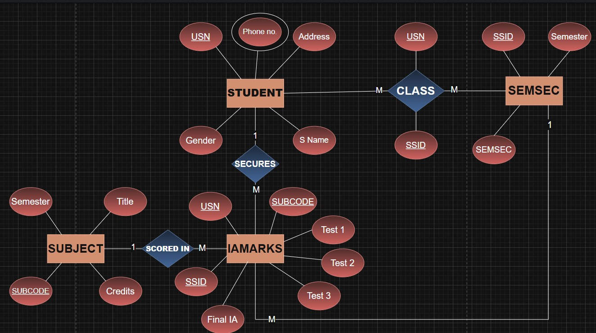

Experiment : 2
Question 2. Consider following databases and draw ER diagram and convert entities and relationships to relation table for a given scenario:

COMPANY DATABASE
EMPLOYEE (SSN, Name, Address, Salary, Sex, SuperSSN, DNO)
DEPARTMENT (DNo, DName, MgrSSN, MgrStartDate)
PROJECT (PNo, PName, PLocation, DNO)
DLOCATION (DNo, DLoc)
WORKS_ON (SSN, PNo, Hours)
MANAGES (SSN, DNo)
Solution:
- The entities EMPLOYEE, DEPARTMENT, PROJECT, and DLOCATION are identified and represented using rectangles.
- The attributes are represented using ellipses:
o EMPLOYEE: SSN (Primary Key), Name, Address, Salary, Sex, SuperSSN, DNO ▪ SSN is underlined as it is the Primary Key.
▪ SuperSSN is a foreign key referencing EMPLOYEE (self-relationship). ▪ DNO is a foreign key referencing DEPARTMENT.
- DEPARTMENT: DNo (Primary Key), DName, MgrSSN, MgrStartDate ▪ DNo is underlined as the Primary Key. ▪ MgrSSN is a foreign key referencing EMPLOYEE.
- PROJECT: PNo (Primary Key), PName, PLocation, DNO ▪ PNo is underlined as the Primary Key. ▪ DNO is a foreign key referencing DEPARTMENT.
- DLOCATION: DNo, DLoc
▪ DNo and DLoc together form a composite key. ▪ DNo is a foreign key referencing DEPARTMENT.
o WORKS_ON: SSN, PNo, Hours
- SSN and PNo together form a composite key.
- Hours is a descriptive attribute of the relationship.
  - Primary keys are represented by underlining the attribute names.
  - The relationship WORKS_ON is drawn as a diamond between EMPLOYEE and PROJECT with M : N cardinality, indicating that:
    - One employee can work on many projects. o One project can have many employees.
    - Hours attribute represents the number of hours worked.
  - The relationship MANAGES is drawn between EMPLOYEE and DEPARTMENT with 1 : 1 cardinality, indicating:
    - One employee manages one department.
    - Each department has one manager.
  - The relationship between EMPLOYEE and DEPARTMENT (via DNO) is M : 1, meaning:
    - Many employees work in one department.
  - The relationship between DEPARTMENT and PROJECT is 1 : M, meaning:
    - One department controls many projects.
    - Each project belongs to one department.
  - The relationship between DEPARTMENT and DLOCATION is 1 : M, meaning: o One department can have multiple locations.
  - A recursive relationship exists in EMPLOYEE through SuperSSN, representing that:
    - One employee can supervise many employees.
  - All entities, attributes, relationships, primary keys, foreign keys, and cardinalities are clearly represented in the ER diagram.
ER DIAGRAM:
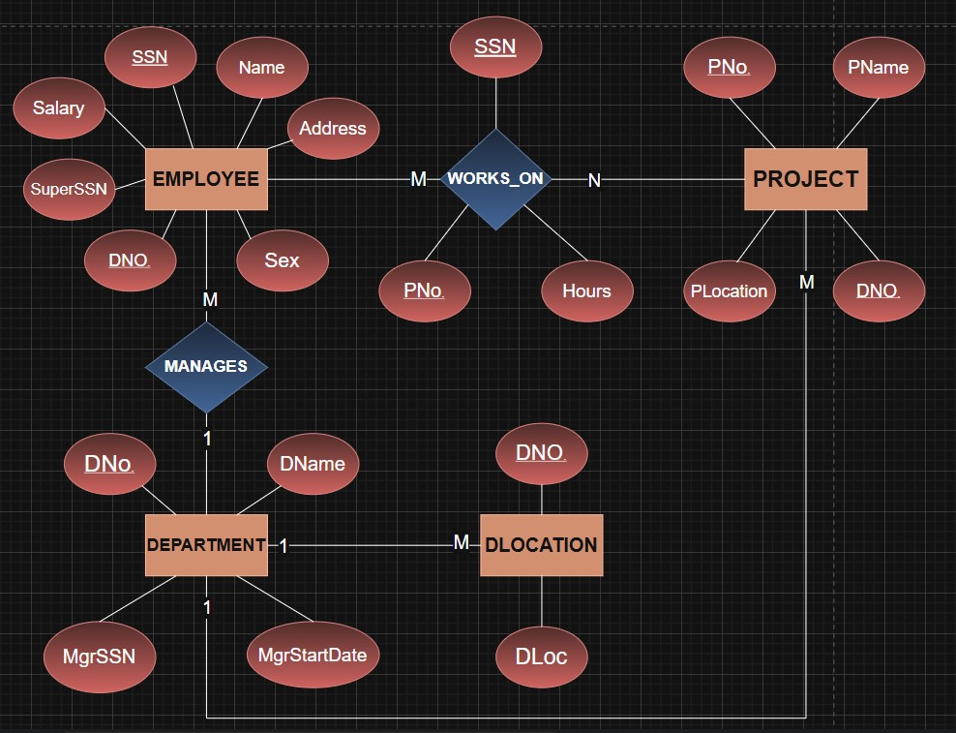
Experiment : 3
Question : Database Schema for a customer-sale scenario
Customer(Cust id : integer, cust_name: string)
Item(item_id: integer, item_name: string, price: integer)
Sale(bill_no:integer,bill_data:date,cust_id: integer, item_id: integer, qty_sold: integer)
For the above schema, perform the following—
- Create the tables with the appropriate integrity constraints.
Output:
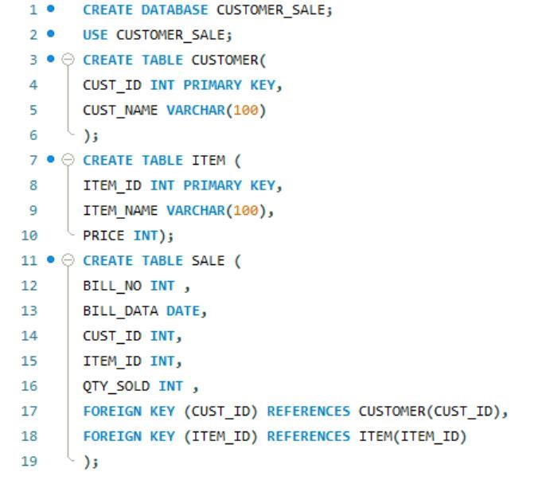
- Insert around 10 records in each of the tables.
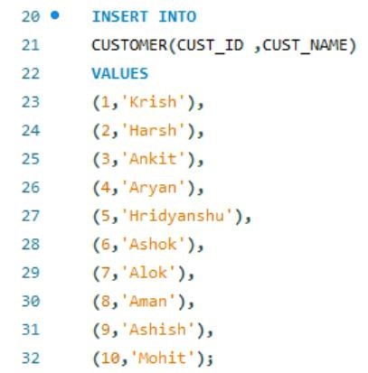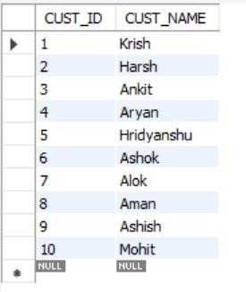

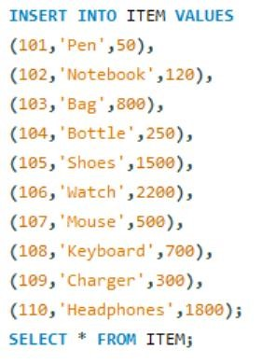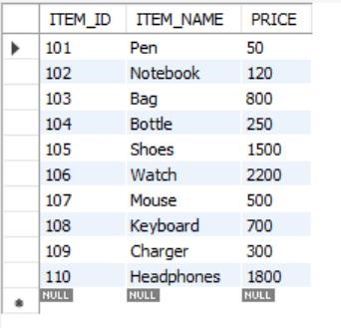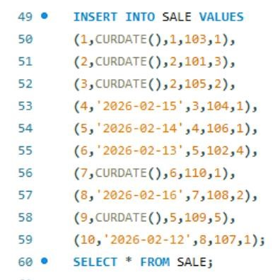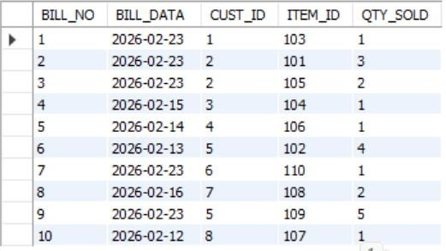

3.List all the bills for the current date with the customer names and item numbers
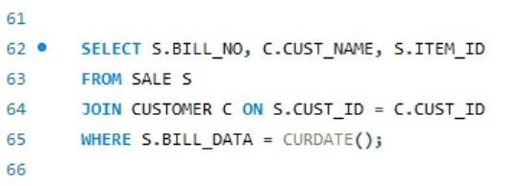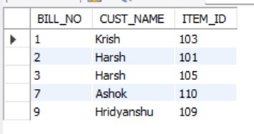

4. List the total Bill details with the quantity sold, price of the item and the final amount.
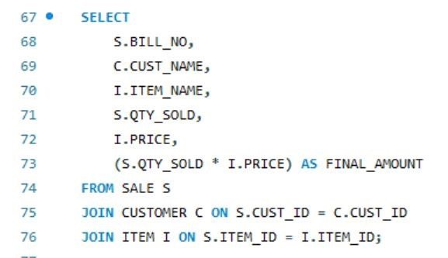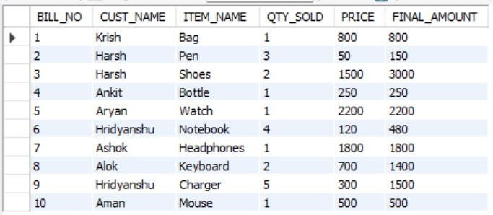

5.List the details of the customer who have bought a product which has a price>200
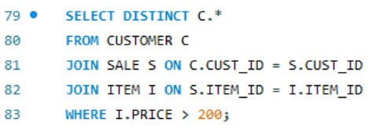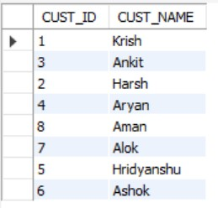

6.Give a count of how many products have been bought by each customer
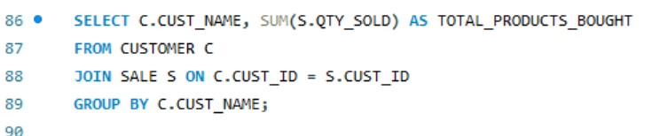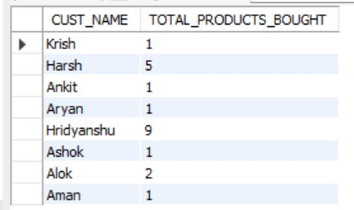

7.Give a list of products bought by a customer having cust_id as 5.
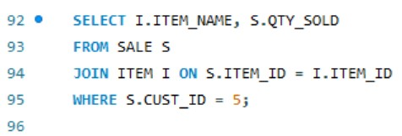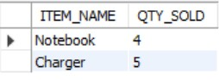

8.List the item details which are sold as of today.
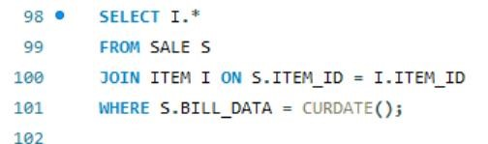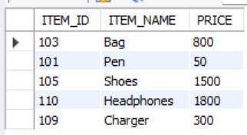

9. Create a view which lists out the bill_no, bill_date, cust_id, item_id, price, qty_sold,Amount
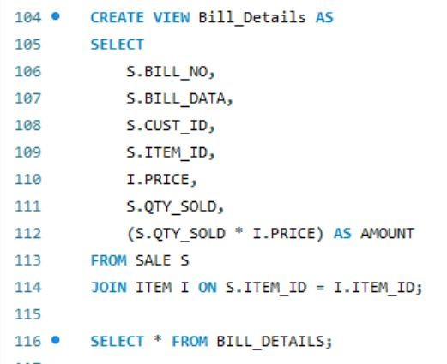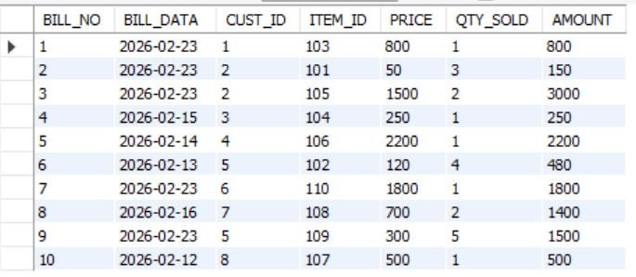

10.Create a view which lists the daily sales date wise for the last one week
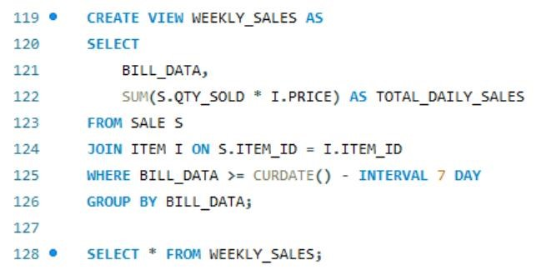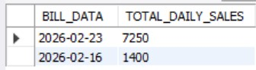

Experiment : 4
Question : Consider the following table: Table: CLASS (ID,Name)
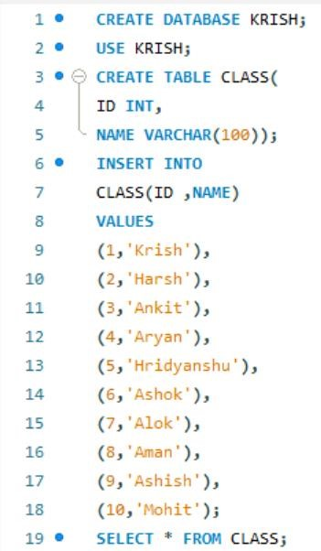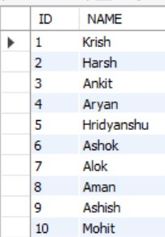

1.SET AUTOCOMMIT = 0; and START TRANSACTION;
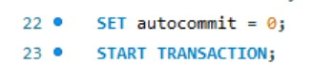

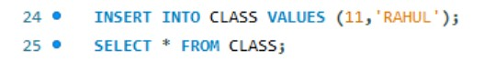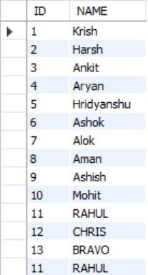
2
.
INSERT INTO class
VALUES (
11
,’
Rahul
’);

3.UPDATE class SET name = ‘Abhijeet’ WHERE id= ‘5’;
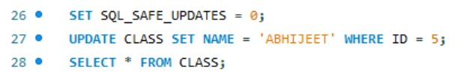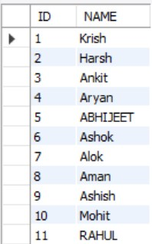

4.

SAVEPOINT A
:

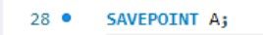
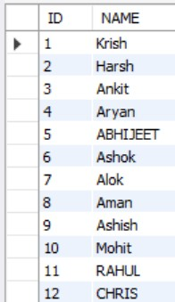
5.

INSERT INTO class VALUES (
12
, ‘
Chris
’);

6.

SAVEPOINT B
;

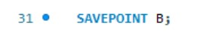
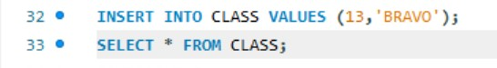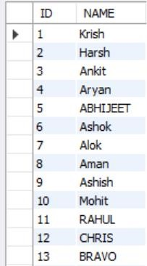
7.

INSERT INTO class VALUES (
13
, ‘
Bravo
’);

8.SAVEPOINT C;
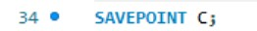

9
.
ROLLBACK TO B;

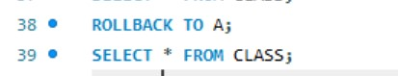
10
.ROLLBACK TO A;

11. COMMIT;
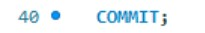

Experiment : 4.2
Consider the following table: Table: ACCOUNT_TXN
Acc_ID Holder_Name Balance
- Aman 5000
- Bhavna 7000

103 Chirag 6000
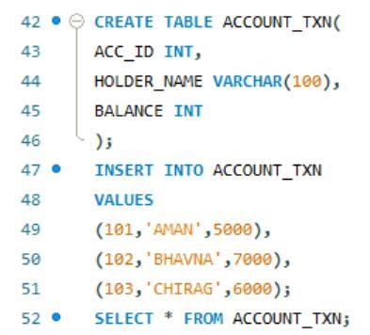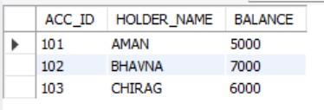
Perform the following TCL-based SQL script and write the output after each SELECT statement:

1.INSERT INTO ACCOUNT_TXN VALUES (104, 'Diya', 4000);
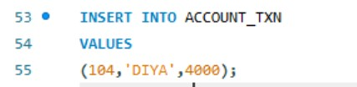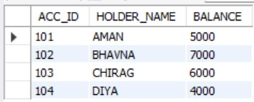

2.SAVEPOINT S1
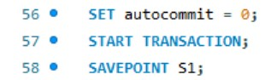

3. UPDATE ACCOUNT_TXN SET Balance = Balance + 1500 WHERE Acc_ID = 101
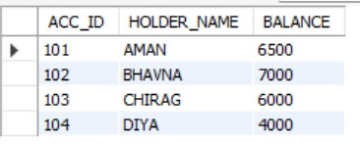

4. UPDATE ACCOUNT_TXN SET Balance = Balance - 1000 WHERE Acc_ID = 102
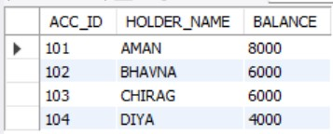

5. SAVEPOINT S2;
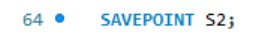

6. DELETE FROM ACCOUNT_TXN WHERE Acc_ID = 103
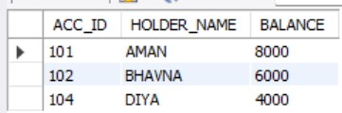

7. INSERT INTO ACCOUNT_TXN VALUES (105, 'Eshan', 3000);
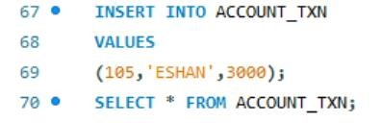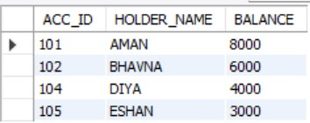

8.SAVEPOINT S3
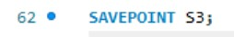

9. UPDATE ACCOUNT_TXN SET Holder_Name = 'Bhavna Sharma' WHERE Acc_ID = 102;
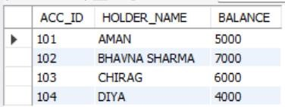

11.ROLLBACK TO S2;
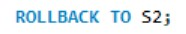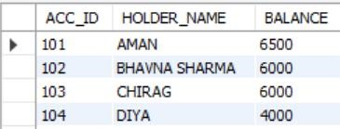

12.INSERT INTO ACCOUNT_TXN VALUES (106, 'Farah', 4500)
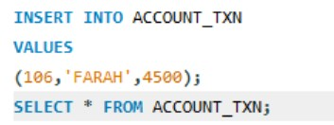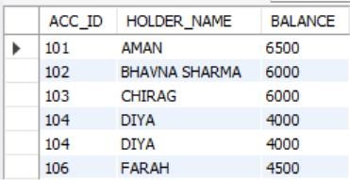

13.
SAVEPOINT S4;

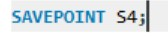

14.UPDATE ACCOUNT_TXN SET Balance = Balance + 500 WHERE Acc_ID IN (101,104); SELECT * FROM ACCOUNT_TXN
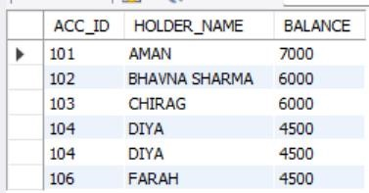

15.ROLLBACK TO S4;

SELECT * FROM ACCOUNT_TXN;
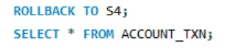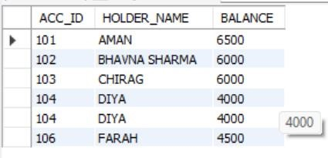

16.COMMIT
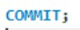
17.Identify which rows are permanently saved after COMMIT.
